Commitment Form
2019 Preparing America’s Patriots Dinner

Tuesday, June 11th, 2019
Great Wolf Lodge
6:30 PM-8:30 PM

Benefiting
Hopewell District, Dan Beard Council, BSA

____ Platinum Sponsor ($5,000): 24 event tickets; back cover of the program or full page ad in program;
__________Company listing in the event program; verbal recognition during the event; company logo featured
__________in the program; company logo displayed at the event; an opportunity to speak on behalf of the
__________company’s partnership with the BSA.
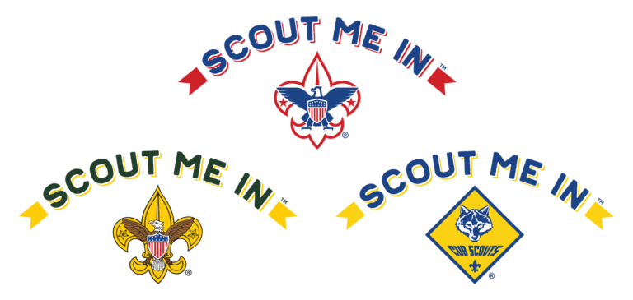
____ Diamond Sponsor ($4,000): 20 event tickets; half page ad in the program; company listing in the event
__________program; verbal recognition during the event; company logo featured in the program; company logo
__________displayed at the event.

____ Gold Sponsor ($3,000): 16 event tickets; quarter page ad in the program; visual recognition during
__________the event; company logo featured in the program; company logo displayed at the event.

____ Silver Sponsor ($2,000): 12 event tickets; company listing in the event program; visual recognition
__________during the event; company logo featured in the program.

____ Bronze Sponsor ($1,000): 8 event tickets; company listing in the event program; visual recognition
__________during the event.

____ Individual Ticket ($100): One ticket to the event. If purchasing more than one ticket, please write
__________how many tickets you are purchasing in the box.

Name/Company: _______________________________________________________________________________

Billing Address:_________________________________________________________________________________

City:________________________________ State: ____________ Zip: _____________________________________

Phone: _____________________________ Email: _____________________________________________________

Signature: ______________________________________ Payment Method (CC, Check, Bill Me): _______________

Credit Card #: ___________________________________ Exp. Date: _______________ V-Code: _______________

Please return your form/check (payable to Dan Beard Council) to Dan Beard Council, 10078 Reading Road, Cincinnati OH 45241. The Dan Beard Council is
501(c)(3) charitable organization. According to IRS regulations, we are required to inform donors that the amount of a deductible contribution is limited
To the excess of money paid over the fair market value of goods and services received. The fair market value of this event for one person is $20.

Tuesday, June 11th, 2019
6:30-8:30 PM
Great Wolf Lodge

